SPECIAL IMPROVEMENT DISTRICT OF NETCONG BOROUGH, INC.
NETCONG COMMUNITY PARTNERSHIP
BOARD OF TRUSTEES MEETING
April 25, 2024
6:30 PM
AGENDA

- Call to Order

- Attendance and Roll Call

 | Present | Absent
Ryan Barsa
Michael Downing
Stephen Fredericks
Bob Hathaway
Norma Morales
Joseph Nametko
Marty Pisano
Sam Raza
Michelle Ruocco
Leigh Ann Von Hagen

- President’s Report
  - NCP Pamphlet
  - NJEDA Local Property Acquisition Grant/Letter of Support
  - Assessment of banners, holiday decorations, and flower pot placement

- Approval of Minutes & Treasurer Report

- Committee Assignments

  - Executive Committee: Stephen Fredericks, Chair
Administrative Issues, Insurance, Accounting, Establishes Committee Budgets, and Yearly Audits

  - Finance Committee
Budgets, Grants, Revenue Building

  - Community Outreach Committee: Leigh Ann Von Hagen, Chair
Netcong Day, Holiday Events and New Events

  - Publishing Committee: Marty Pisano, Chair
Website, Directory, Community Calendar, Street Map including Events Locations, Social Media

  - Property Enrichment – Streetscape/Town Center/Economic Development:
Bob Hathaway, Chair
Improvements and Enhancements, Signage, Fixtures, Owners Assistance Program, Façade/Sign Application Program and Submitted Application Review

  - By Laws and Legal Issues: Michael Downing, Chair
Corporate By-Laws Maintenance and Legal Issues

- Economic Development update – Bob Hathaway

- Motion to approve the bills list for April, 2024.

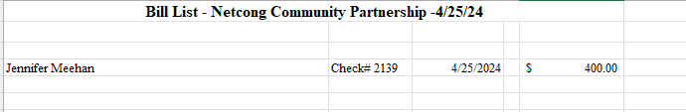

 | Motion | Second | Yes | No | Abstain | Absent
Ryan Barsa
Michael Downing
Stephen Fredericks
Bob Hathaway
Norma Morales
Joseph Nametko
Marty Pisano
Sam Raza
Michelle Rucco
Leigh Ann Von Hagen

- Old Business:

- New Business:

- Adjournment

